**Street Maniax**

**Street Maniax website Link :** [**https://streetmaniax.com/**](https://streetmaniax.com/)

**Street Maniax wordpress Link :** [**https://streetmaniax.com/wp-admin/**](https://streetmaniax.com/wp-admin/)

**WordPress Login Credentials :**

**User : root**

**Password : IN8oY9oPWNKDBOr5^oD$X%NR**

**WordPress Version : 6.8.1**

**PHP Version : 7.4.33**

**Plugins**

1. **ACF Photo Gallery Field :**

The **ACF Photo Gallery Field** is a WordPress plugin that extends Advanced Custom Fields (ACF) to let you add photo galleries to posts or pages. It stores images as post metadata and provides a helper function acf_photo_gallery(ACF_FIELD_NAME, POST_ID) to retrieve image data (like title, caption, URL, etc.) as an array. You can display the gallery using any front-end framework (e.g., Bootstrap). It also supports extra image fields, custom captions, and REST API integration.

1. **Advanced Custom Fields (ACF®) :**

**Advanced Custom Fields (ACF)** enhances WordPress by letting you add custom fields to posts, pages, users, and more—without writing code. Using its visual field builder, you can easily define structured content (like text, images, or repeaters). These fields can be displayed in your theme using simple PHP functions like get_field(). ACF Pro adds advanced features like repeaters, flexible layouts, galleries, and custom blocks for Gutenberg. It helps developers and content creators manage data-rich sites efficiently.

1. **Advanced Custom Fields Multilingual :**

This ACFML glue plugin connects **Advanced Custom Fields (ACF)** with WPML (WordPress Multilingual Plugin), making it easy to translate custom fields into multiple languages. It ensures that content created with ACF—like text, images, repeaters, and flexible content—is recognized and translatable by WPML’s interface. With this plugin, you can smoothly manage multilingual content across all ACF field types without manual duplication or custom code.

1. **All-in-One WP Migration and Backup:**

All-in-One WP Migration works by allowing you to export your entire WordPress website—including the database, media files, plugins, and themes—into a single .wpress file with just one click. You then install the plugin on the destination site and simply drag and drop the file to import and fully restore your website. The process is designed to be seamless, requiring no technical skills and causing no downtime during migration.

1. **All-in-One WP Migration Unlimited Extension:**

The All-in-One WP Migration Unlimited Extension is a premium add-on that removes the upload and export size limits imposed in the free version of the plugin. With this extension, you can migrate websites of any size, whether it’s a small blog or a large enterprise portal. It’s especially useful for users with heavy media libraries, large databases, or complex WordPress setups, and it works seamlessly with the core plugin to ensure fast, reliable, and unrestricted migration or backup operations.

1. **Classic Editor :**

The **Classic Editor** plugin disables the Gutenberg block editor and restores the old WordPress editor (TinyMCE). It lets admins set the default editor and allows users to choose per post. It supports legacy plugins and meta boxes, ensuring a consistent editing experience.

1. **Classic Widgets :**

The **Classic Widgets** plugin restores the old WordPress widget interface, disabling the block-based widget editor. When activated, it brings back the classic widget settings screen for classic themes, with no extra setup needed. Just enable or disable the plugin to switch widget interfaces.

1. **Contact Form 7 :**

**Contact Form 7** is a free and open-source WordPress plugin that lets you create and manage contact forms easily. It uses a modular architecture and custom validation system. The plugin doesn’t store user data or use cookies by default, but optional integrations (like reCAPTCHA or Stripe) may handle personal data. It’s privacy-conscious, flexible, and widely supported by a large community.

1. **Contact Form 7 – Dynamic Text Extension :**

**Contact Form 7 – Dynamic Text Extension (DTX)** enhances Contact Form 7 by allowing you to pre-fill form fields dynamically using shortcodes. It supports auto-populating data like post titles, user info, URLs, cookies, custom fields, and more. You can set dynamic values, placeholders, and even make fields read-only or obfuscated for privacy. It’s also cache-friendly, supports client-side rendering, and allows custom shortcodes for full flexibility. DTX makes Contact Form 7 smarter and more personalized for users and site data.

1. **Contact Form 7 Multilingual :**

**Contact Form 7 Multilingual** is a WPML add-on that allows you to translate Contact Form 7 forms without creating separate forms for each language. You build the form once in CF7, and then use WPML to manage translations, keeping the structure intact and simplifying multilingual form management.

1. **Contact Form 7 Database Addon – CFDB7 :**

**CFDB7** is a plugin that automatically saves Contact Form 7 submissions to your WordPress database with no setup required. It stores all form entries in a single table and allows you to view, export (CSV/PDF), or import (CSV) data. It also offers developer-friendly features, email testing tools, and optional pro add-ons like Excel export, external DB connection, drag & drop uploads, and popup messages for enhanced form interaction.

1. **Converter for Media:**

Converter for Media is an image optimization plugin that converts your JPEG, PNG, and GIF files to modern WebP and AVIF formats, reducing file size and speeding up your website. With one click, it optimizes your entire Media Library, and all new images are converted automatically. The PRO version adds AVIF support, even smaller file sizes, and compatibility with theme and plugin images — all while ensuring full browser support and no changes to your original files.

1. **Country & Phone Field Contact Form 7 :**

**Country & Phone Field Contact Form 7** is an add-on for Contact Form 7 that adds two new field types: a country drop-down with flags and a phone number field with country code extensions. Once installed, you can use the form tags country drop-down and phone number in your CF7 forms. It requires Contact Form 7 to function and enhances forms with intuitive international phone and country selection.

1. **Date Time Picker for Contact Form 7 :**

**Date Time Picker for Contact Form 7** enhances text fields by turning them into date, time, or datetime pickers using specific CSS classes. You simply add the class walcf7-datepicker, walcf7-timepicker, or walcf7-datetimepicker to a Contact Form 7 text field. The plugin then automatically loads the appropriate picker. The Pro version offers advanced options like disabling past dates, limiting date/time ranges, choosing 12h or 24h formats, WPML compatibility, and performance optimizations.

1. **Duplicate Page :**

**Duplicate Page** is a plugin that lets you easily clone posts, pages, and custom post types in WordPress with a single click. Once activated, you can configure its settings to choose the default status (draft, published, etc.) and behavior of the duplicated content. After setup, clicking the "Duplicate This" link creates a copy based on your preferences. The Pro version adds advanced options like user role control, custom link titles, post prefix/suffix, redirect options, and more customization features.

1. **LiteSpeed Cache:**

LiteSpeed Cache for WordPress (LSCWP) is a performance plugin that offers server-level caching and optimization features like image compression, CSS/JS minification, lazy loading, and database cleanup. It supports all web servers and integrates well with popular plugins like WooCommerce and Yoast SEO.

When used with LiteSpeed servers or QUIC.cloud CDN, it delivers even faster performance through advanced caching, preload crawling, and support for AVIF/WebP images — all helping to boost your site speed and Core Web Vitals.

1. **WP Mobile Menu:**

**WP Mobile Menu** adds a responsive, customizable mobile menu to your WordPress site with no coding needed. It works with any theme and offers slide-out menus, branding, and multi-level navigation.

The **Pro version** includes advanced features like WooCommerce cart support, live search, custom icons, and page-specific menus — all to enhance mobile usability and user engagement.

1. **WP Mobile Menu:**

Post Types Order lets you easily reorder posts and custom post types using a simple drag-and-drop interface, right from the WordPress admin. It works out of the box with no coding needed, applying the new order automatically across your site.

For advanced control, there's a Pro version with features like taxonomy-based sorting, front-end reordering, and compatibility with WPML, WooCommerce, and more**.**

1. **Rank Math SEO:**

**Rank Math SEO** is a feature-rich WordPress plugin that helps optimize your site for search engines with AI tools, smart automation, and built-in schema support. It integrates with Google Search Console, Analytics, and popular page builders for seamless SEO management.

The **Pro version** adds rank tracking, advanced schema, video SEO, and WooCommerce enhancements to make SEO faster, smarter, and more effective.

1. **Simple Custom Post Order :**

This plugin lets you reorder posts or custom post types easily with drag and drop, directly from the WordPress admin panel. No setup needed—just use the interface. Note: it doesn’t affect custom queries using order or orderby in get_posts or query_posts. Now maintained by Colorlib.

1. **SVG Support:**

**SVG Support** is a WordPress plugin that allows you to securely upload and use SVG files, with built-in sanitization to prevent malicious code. It supports inline rendering, so you can style and animate SVGs directly with CSS and JavaScript.

The plugin is developer-friendly, Gutenberg-compatible, and includes advanced features like role-based access, REST API support, and custom hooks — making it a complete solution for safely using SVGs on your site.

1. **Tracking Code Manager :**

**Tracking Code Manager** allows you to easily manage all third-party tracking scripts (like Google Analytics, Facebook Pixel, etc.) from one dashboard. You can insert codes site-wide or on specific pages, place them in the <head> or <body>, and control visibility by location or privacy compliance. It auto-detects eCommerce plugins to track conversions and avoids code loss during theme or plugin updates.

1. **File Manager:**

File Manager lets you manage files directly from your WordPress dashboard without FTP. You can upload, edit, move, and preview files easily. The free version supports basic operations and includes a built-in code editor. The pro version adds user-specific folders, cloud integration, frontend access, and role-based permissions.

1. **WordPress Mail SMTP :**

**WP Mail SMTP** fixes email delivery by replacing WordPress’s default PHP mail with proper SMTP. It supports major email services like Gmail, SendLayer, SMTP.com, Mailgun, Brevo, and more. The setup wizard makes configuration easy, ensuring your emails reach inboxes reliably.

The Pro version adds features like email logging, resend functionality, open and click tracking, weekly reports, conditional routing, rate limiting, and backup SMTP connections. It helps you manage all outgoing emails efficiently, even on multisite networks. White Glove Setup is available for select mailers. The plugin is developed by the WPForms team.

1. **WPML CMS Navigation :**

CMS Navigation adds useful navigation elements for WordPress sites, like breadcrumb trails, sidebar menus, and dropdown navigation. It's designed to help structure content better while building pages.

1. **WPML ElasticPress :**

WPML ElasticPress extends ElasticPress search to support all WPML languages. It syncs and indexes multilingual content, ensuring accurate search results across every language on your site.

1. **WPML Export and Import:**

WPML Export and Import allows you to easily export and import translation data for posts, pages, and custom post types between different WordPress sites using WPML. It simplifies moving multilingual content by generating XML/CSV files that can be imported on another WPML-enabled site, ensuring translations stay intact.

1. **WPML GraphQL :**

WPML GraphQL adds multilingual capabilities to WPGraphQL, allowing you to query WPML language data and translations directly through the GraphQL schema.

1. **WPML Media Translation :**

Media Translation lets you display different images or media files for each language version of your content using WPML.

1. **WPML Multilingual CMS :**

WPML Multilingual CMS is the core plugin that makes your WordPress site multilingual by enabling content translation and adding essential translation controls.

1. **WPML SEO :**

WPML SEO is a bridge plugin that enables seamless translation of your SEO content with WPML, ensuring multilingual optimization across your site.

1. **WPML Sticky Links :**

Sticky Links ensures internal links never break by automatically updating them when you change permalinks, slugs, or page hierarchy. It keeps all internal links accurate and up to date.

1. **WPML String Translation :**

String Translation lets you translate interface and user-generated strings (like taglines or SEO data) directly in WordPress, without editing .mo files.

**Guide for the Editing**

**For Posts :-**

* For Edit Post.

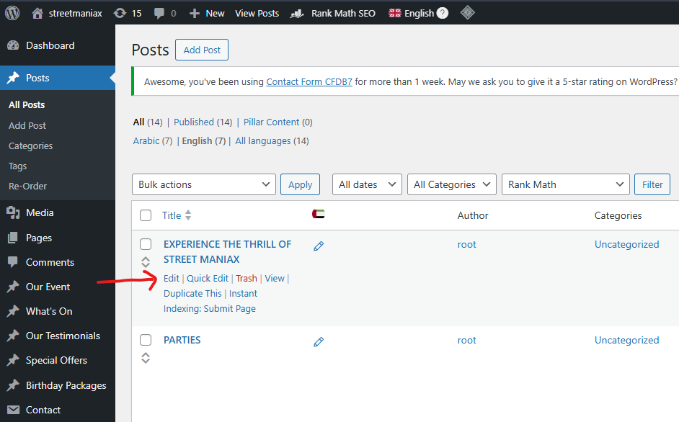

* Post Heading, Description and Link.

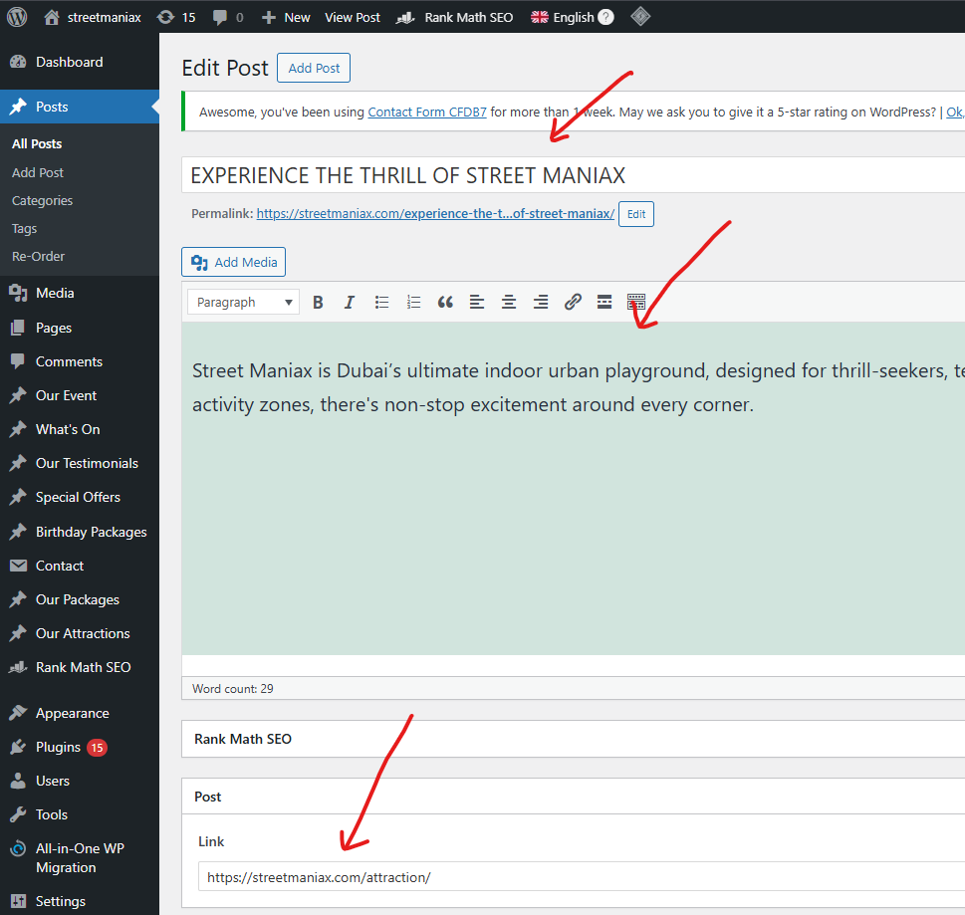

* Post Featured Image.

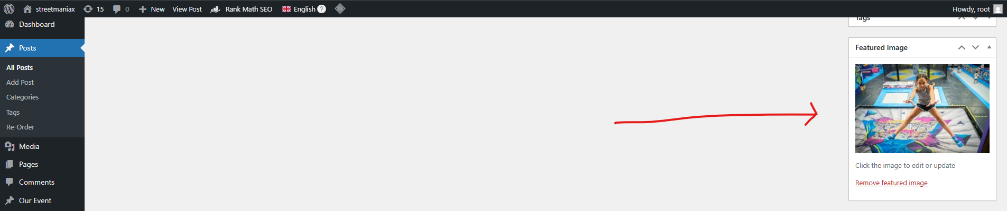

* For Making New Post.

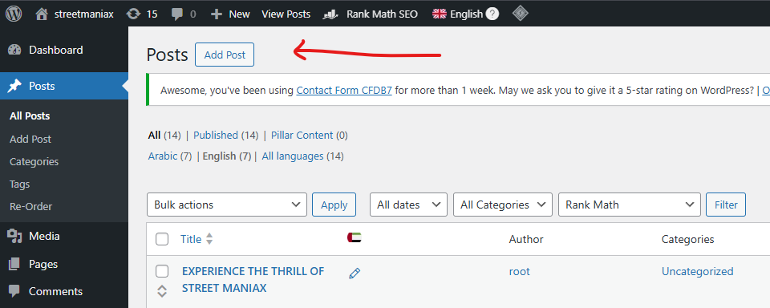

**For Our Events :-**

* For Edit Our Events.

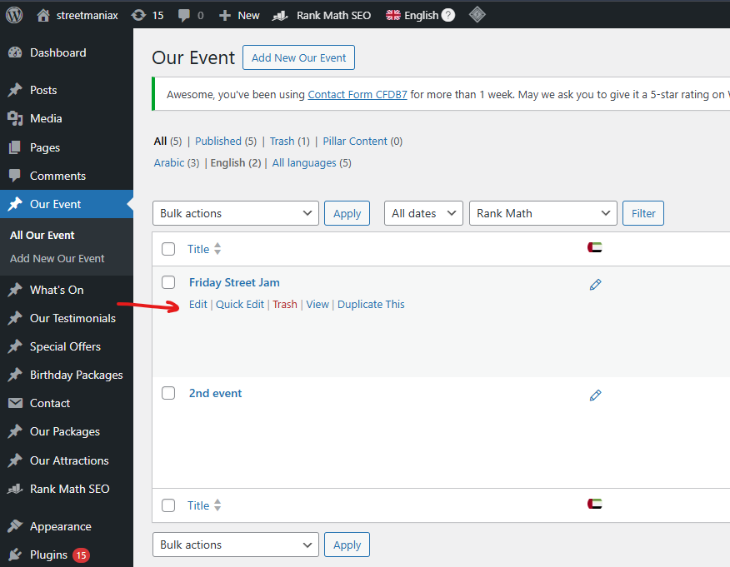

* Our Events Heading and Description.

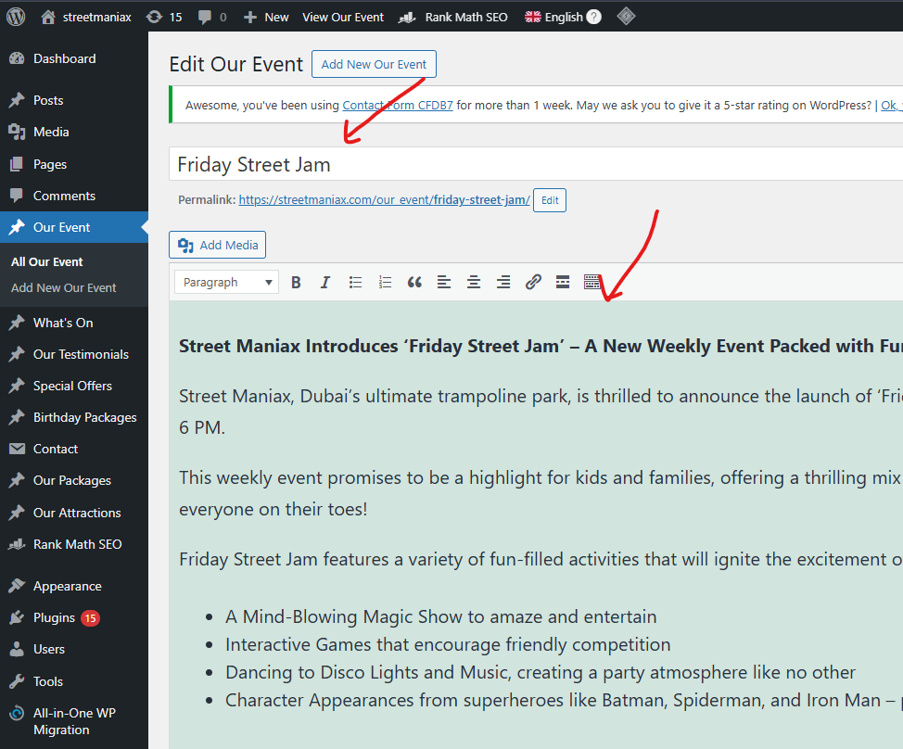

* Event Title.

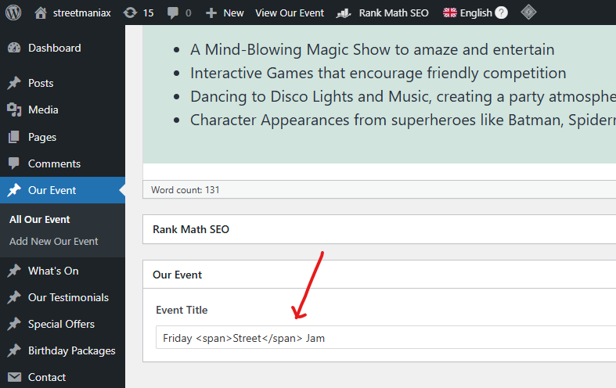

* Event Featured Image.

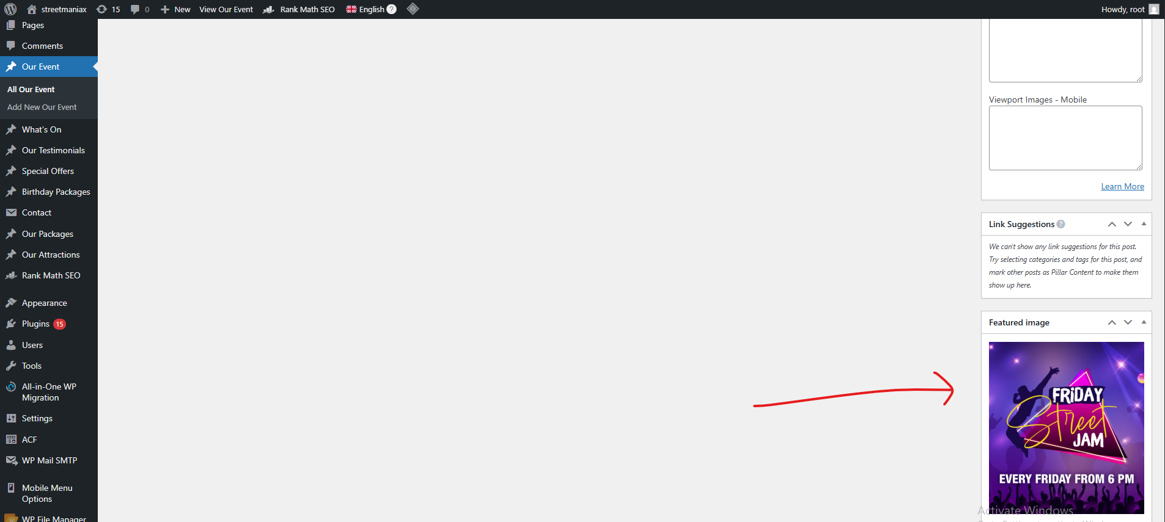

* Add New Event.

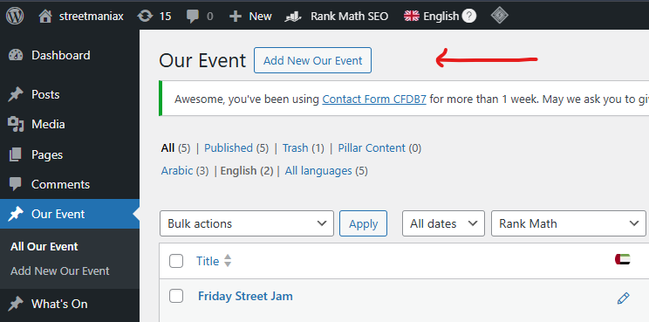

**For Whats On :-**

* For Edit Whats On.

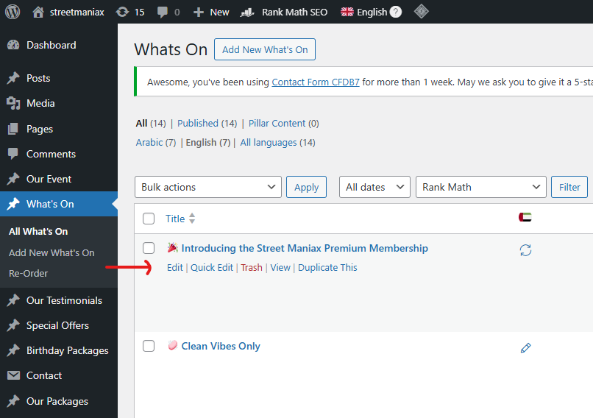

* Whats On Heading and Description.

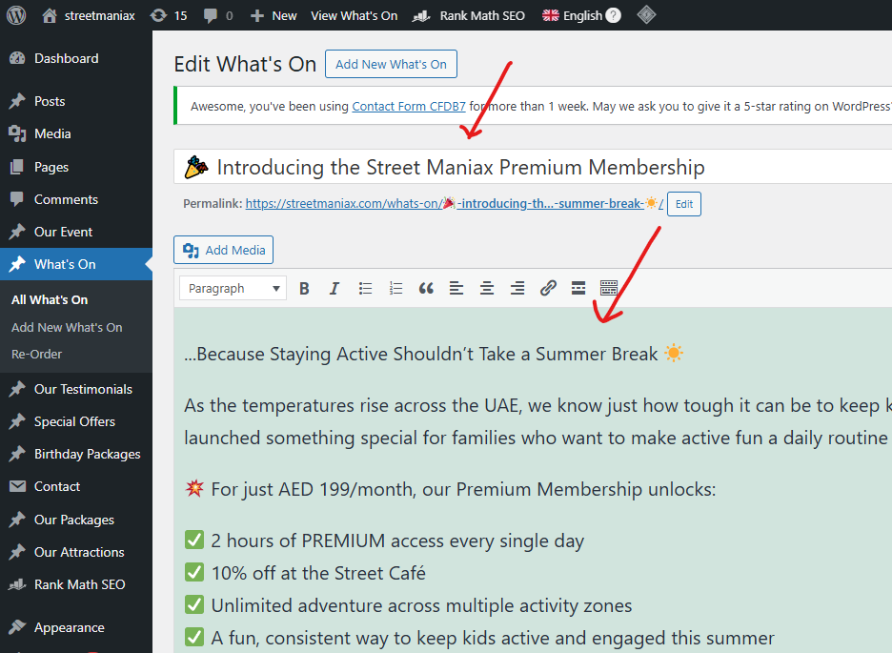

* Whats On Banner Image and Video.

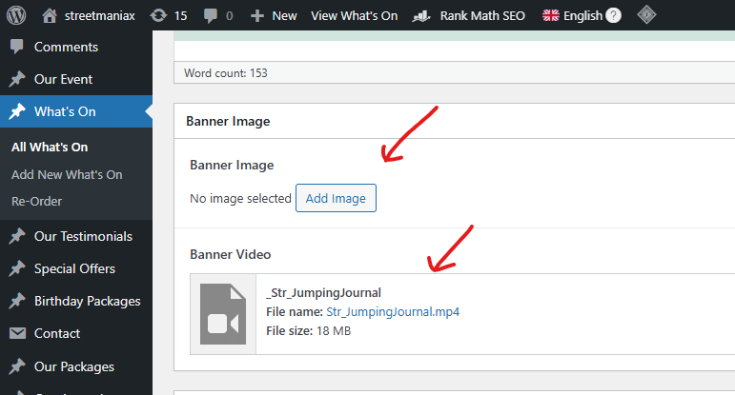

* Whats On Featured Image.

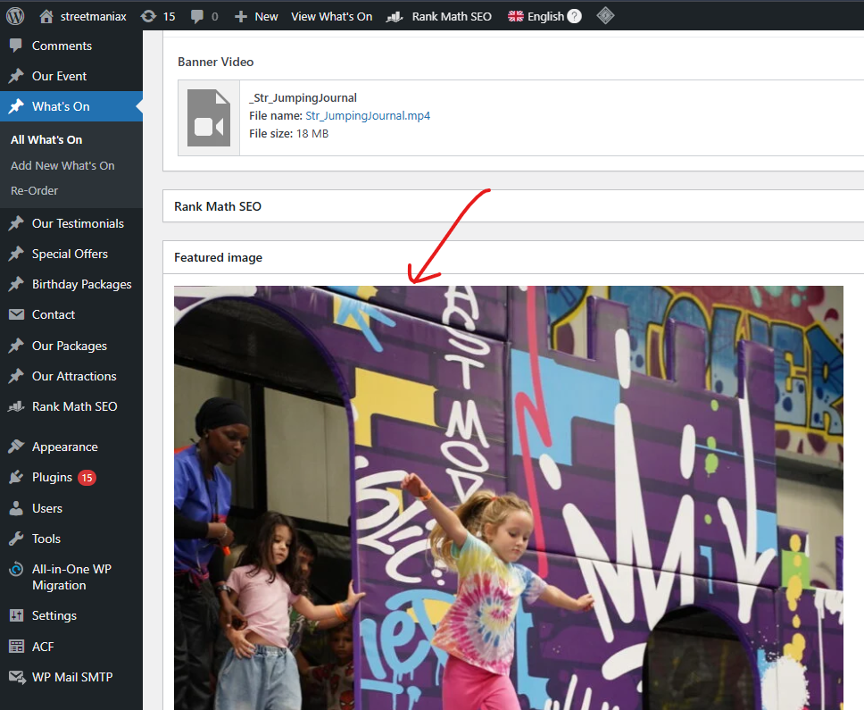

* Add New Whats On.

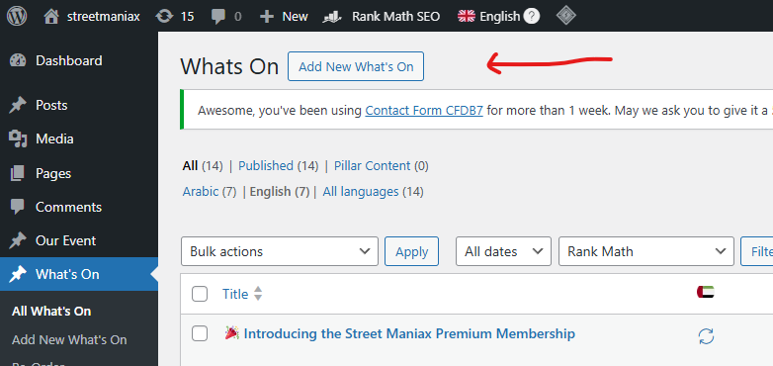

**For Our Testimonials :-**

* For Edit Testimonials.

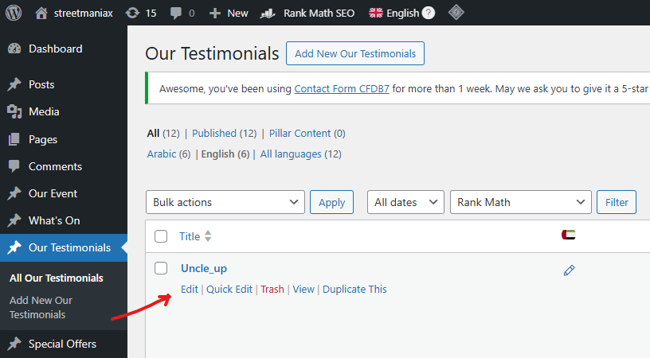

* Testimonial Heading and Description.

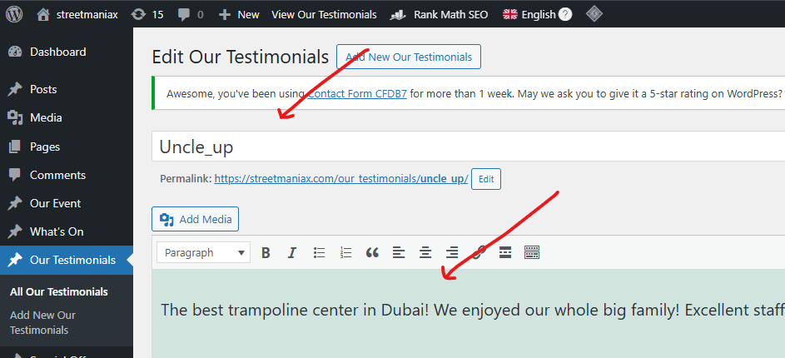

* Testimonial Link.

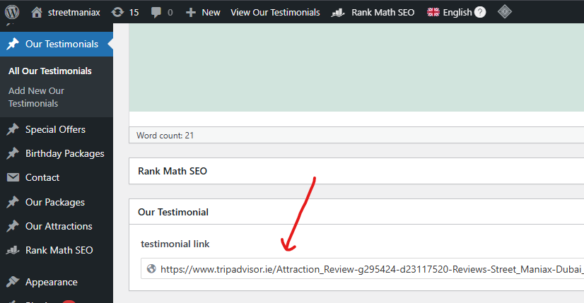

* For New Testimonial.

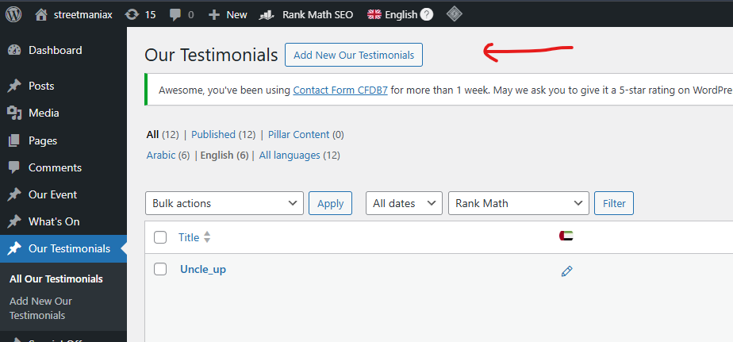

**For Special Offers :-**

* For Edit Special Offers.

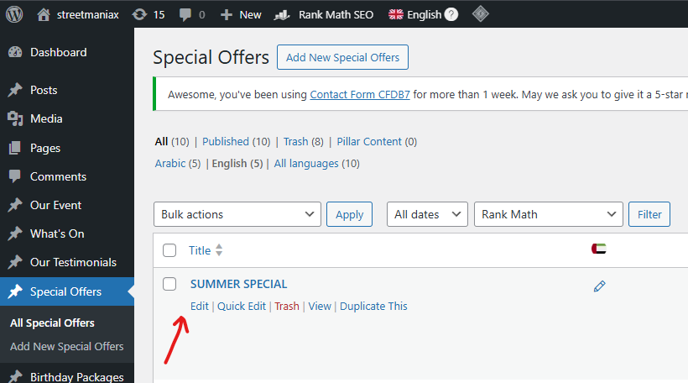

* Special Offers Heading and Description.

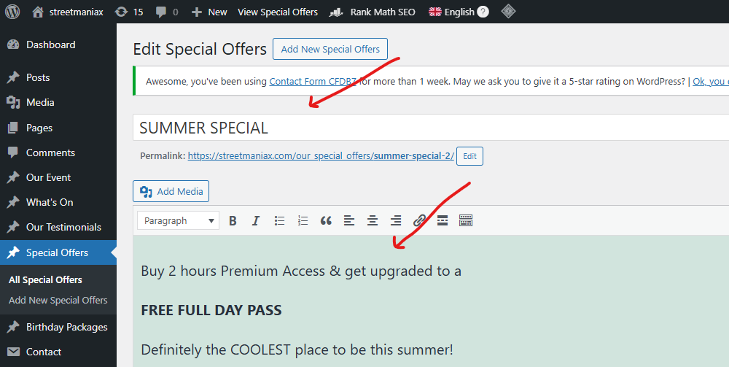

* Special Offers Featured Image.

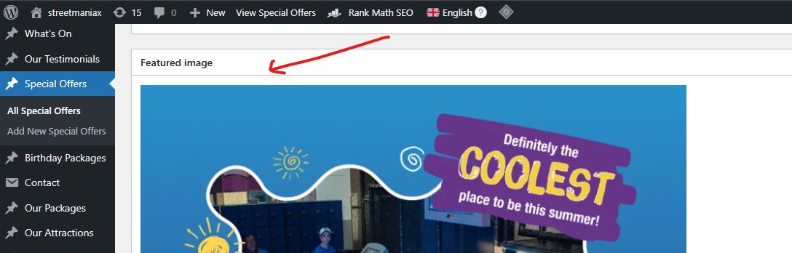

* For New Special Offers.

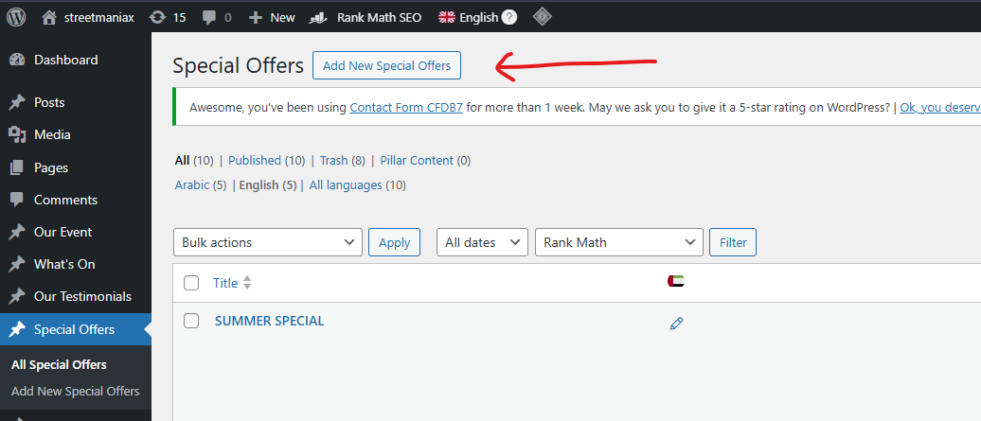

**For Birthday Packages :-**

* For Edit Birthday Packages.

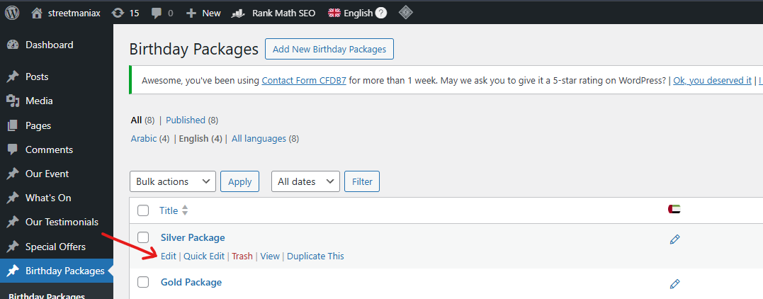

* Birthday Packages Heading and Description.

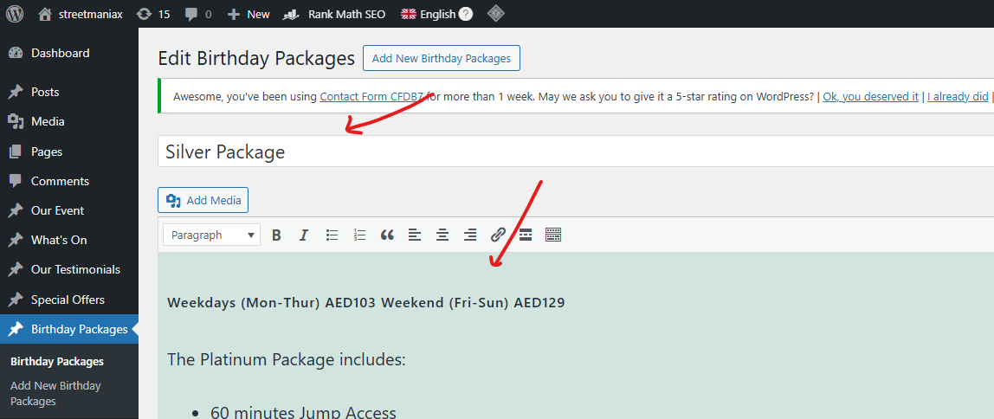

* Birthday Package Link.

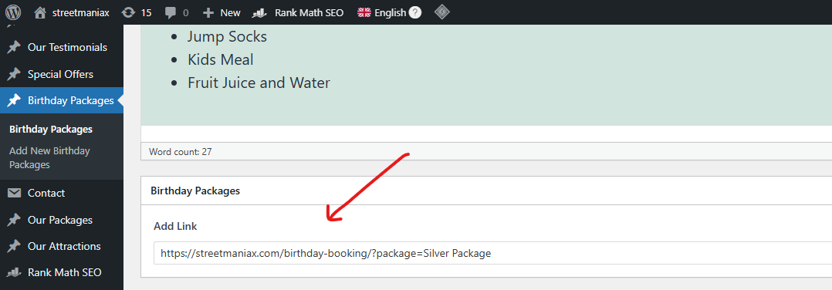

* Birthday Package Featured Image.

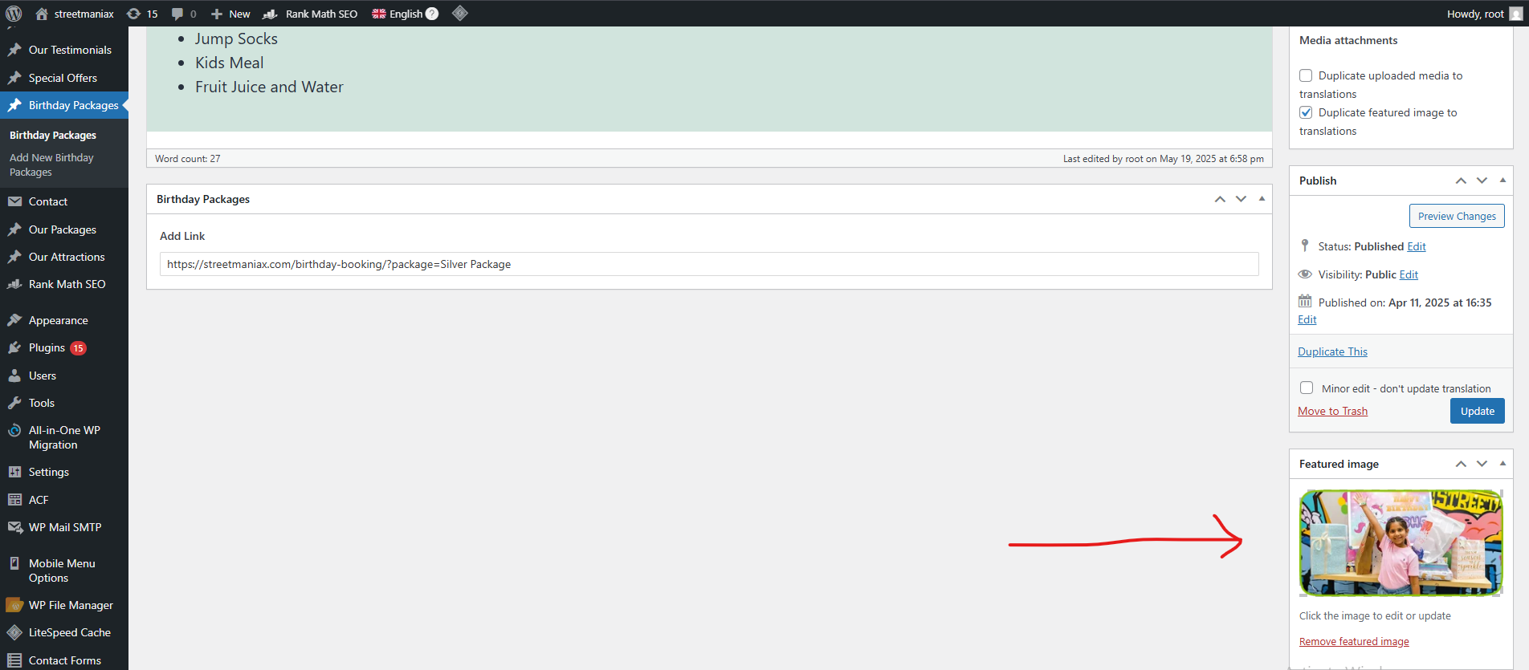

* For New Birthday Package.

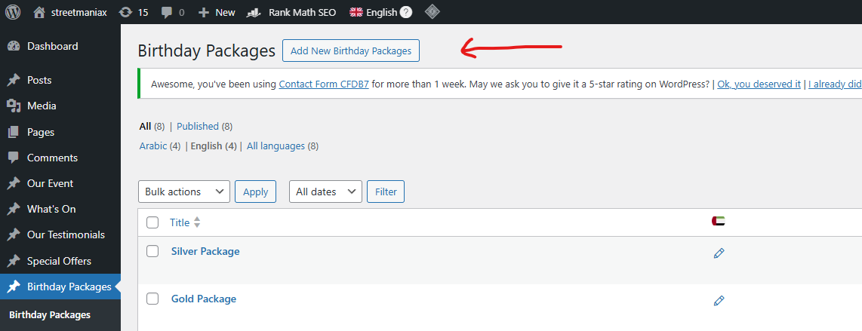

**For Our Packages :-**

* For Edit Our Packages.

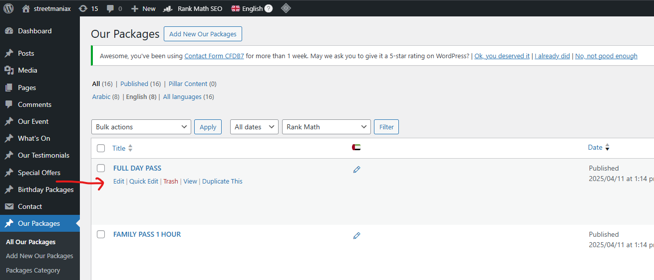

* Our Package Heading and Description.

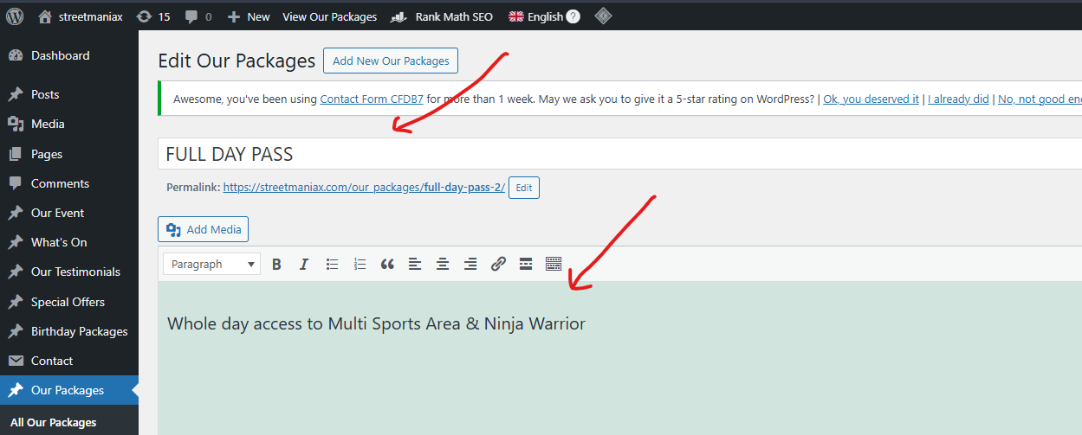

* Our Package Price and Link.

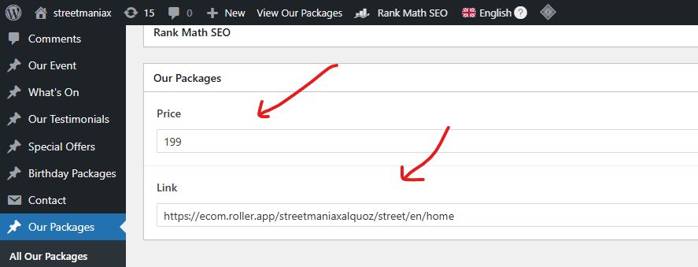

* Our Package Featured Image.

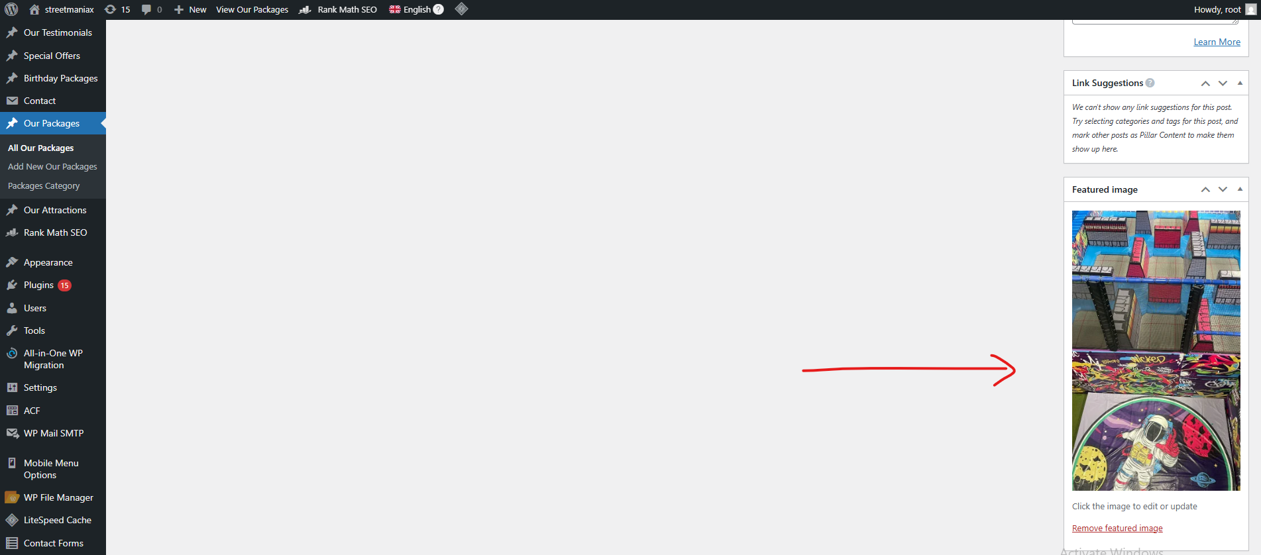

* For Add New Our Package.

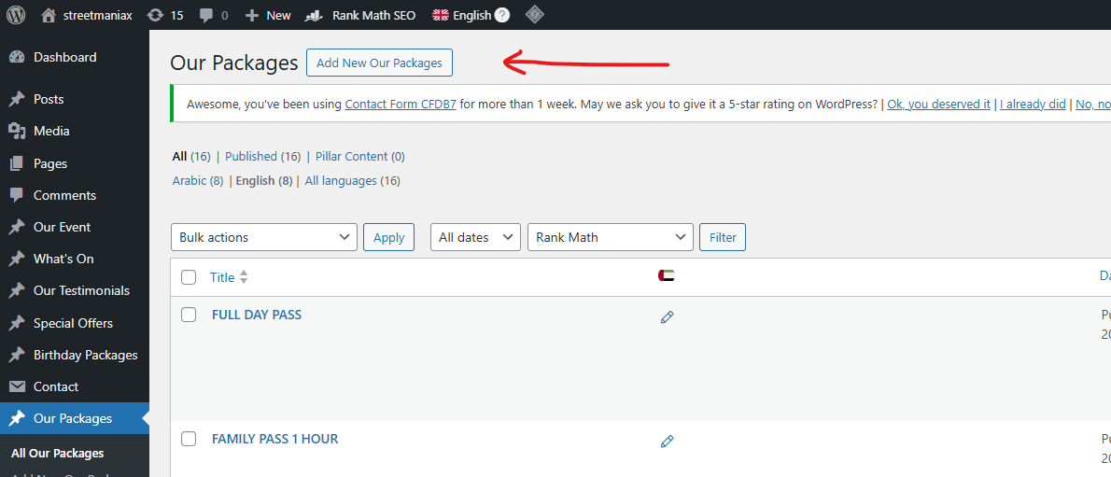

**For Our Attractions :-**

* For Edit Our Attractions.

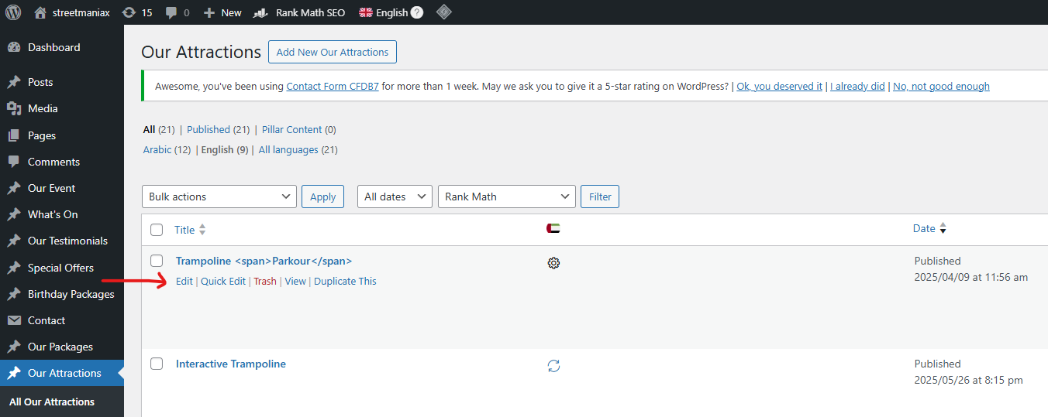

* Our Attraction Heading and Description.

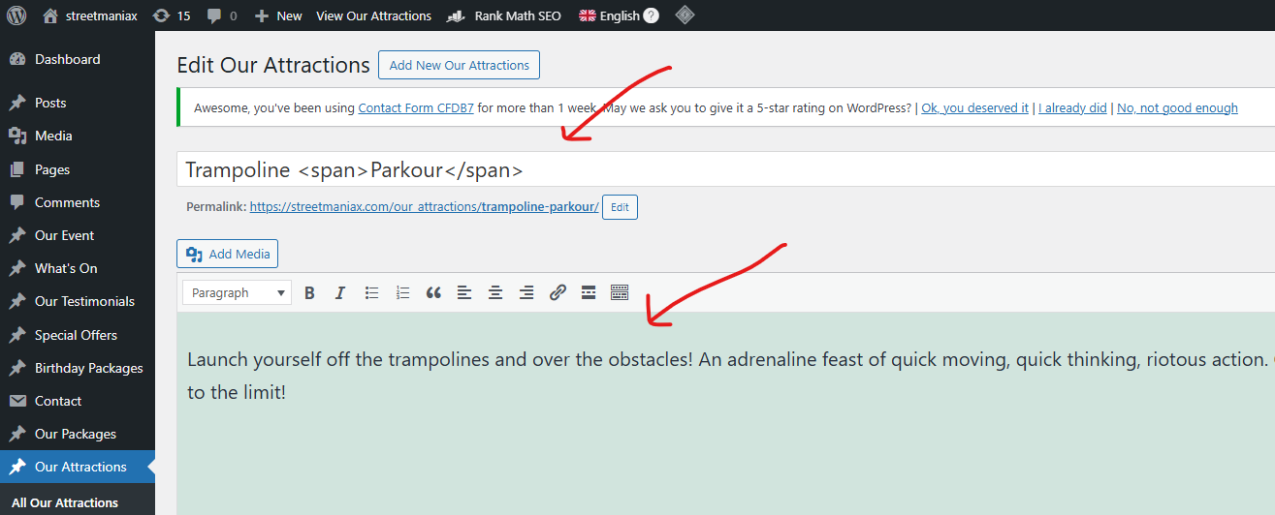

* Our Attraction Featured Image.

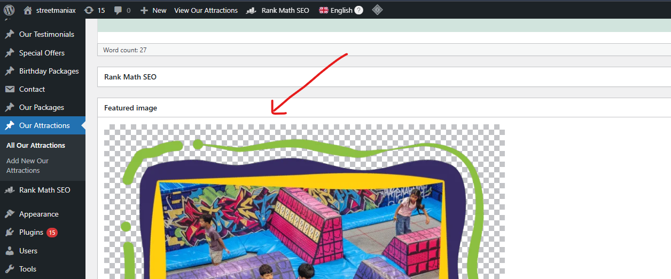

* For Add New Attraction.

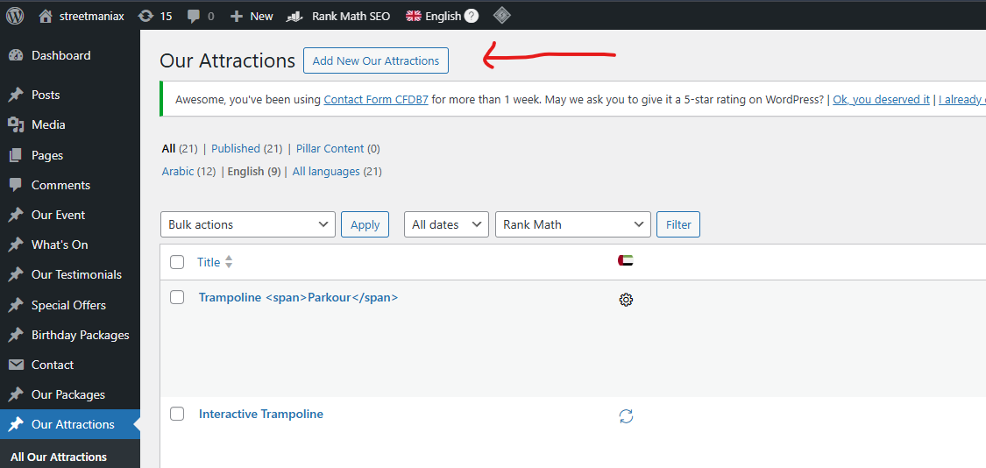

**For Pages :-**

* For Edit Any Page.

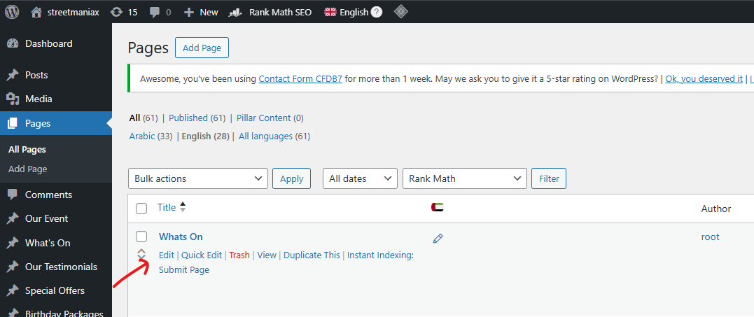

* Page Name and Description if any.

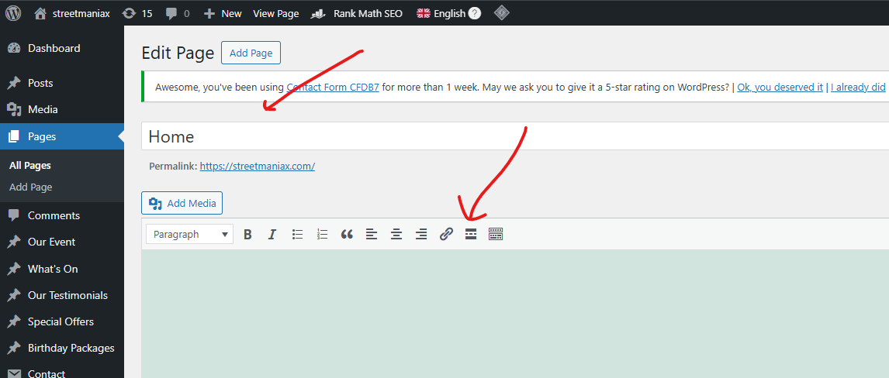

* In this Section, there is a Video link at the top which can be taken from the media, and the other are given the heading according to the sections on the page.

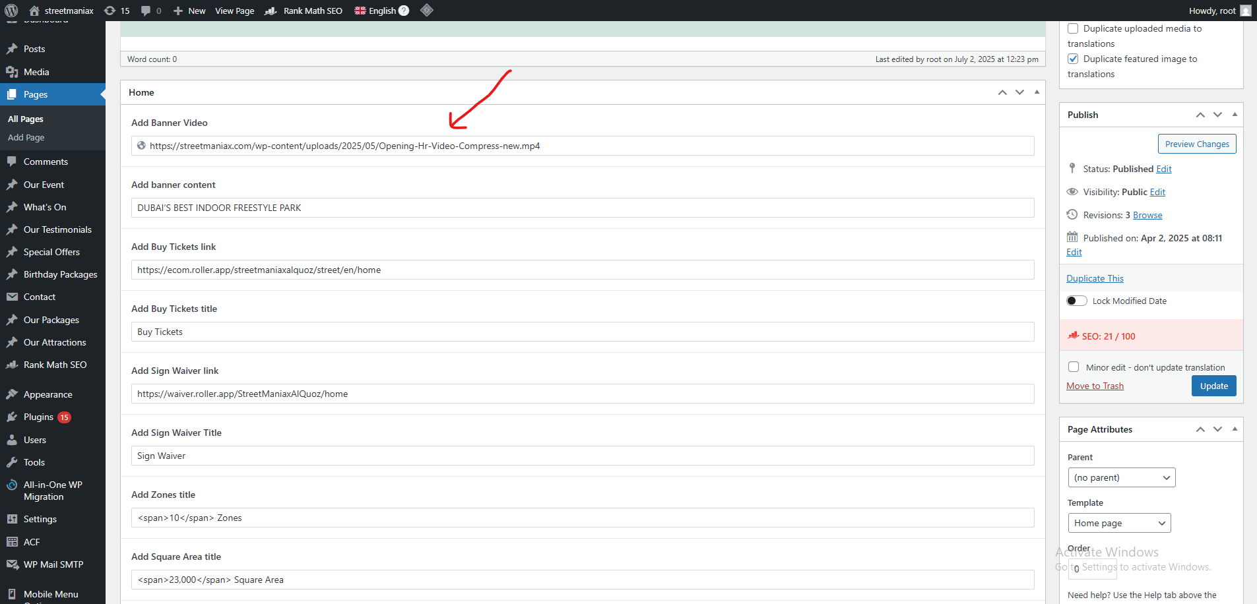

* Slider Images.

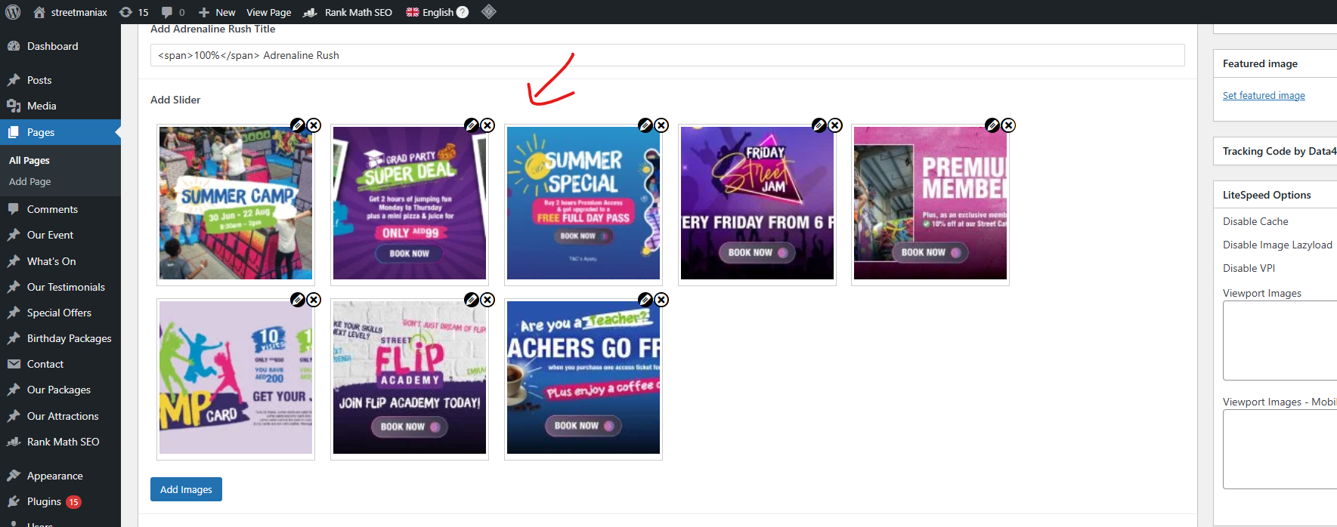

* Details of different sections, their content, and images.

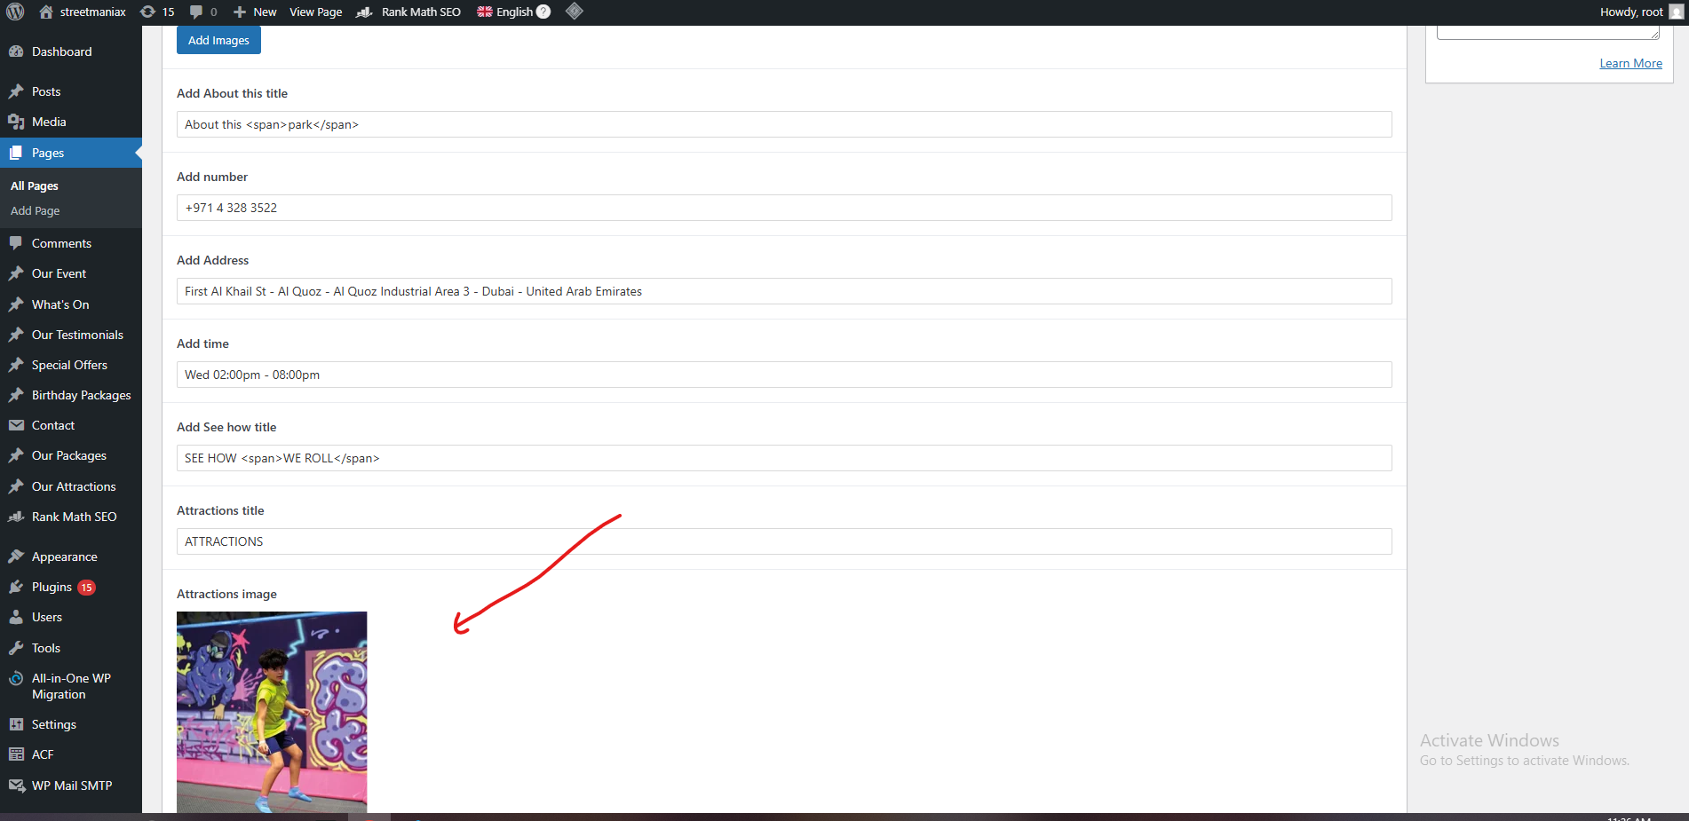

* Shortcode of the Form and link of the map.

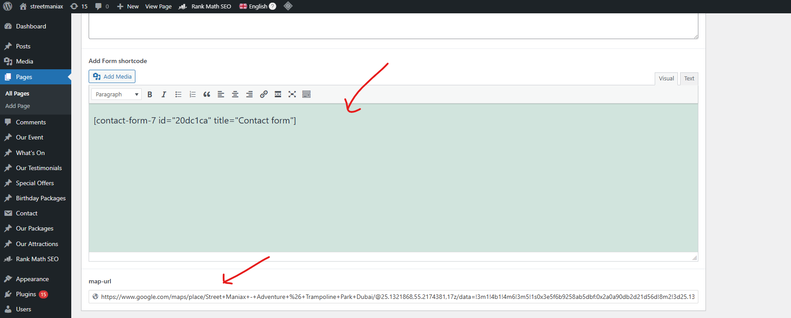

* The Shortcode can be get from the form in the contact.

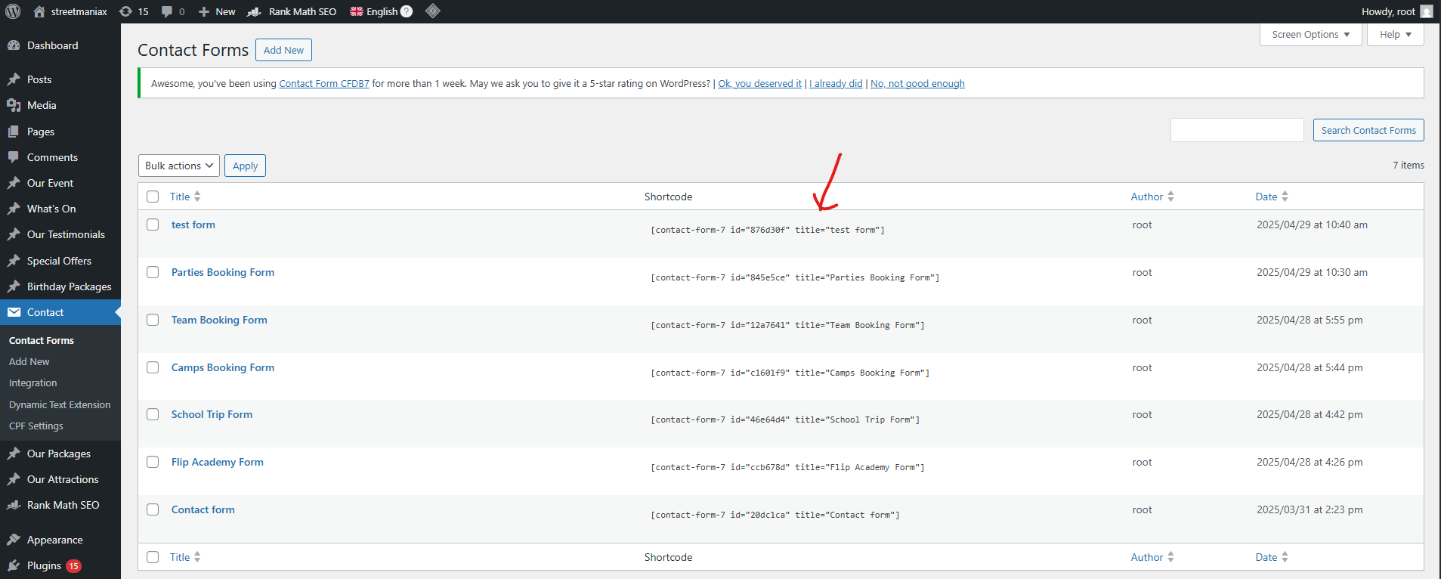

* At last there are Banner image and Video.

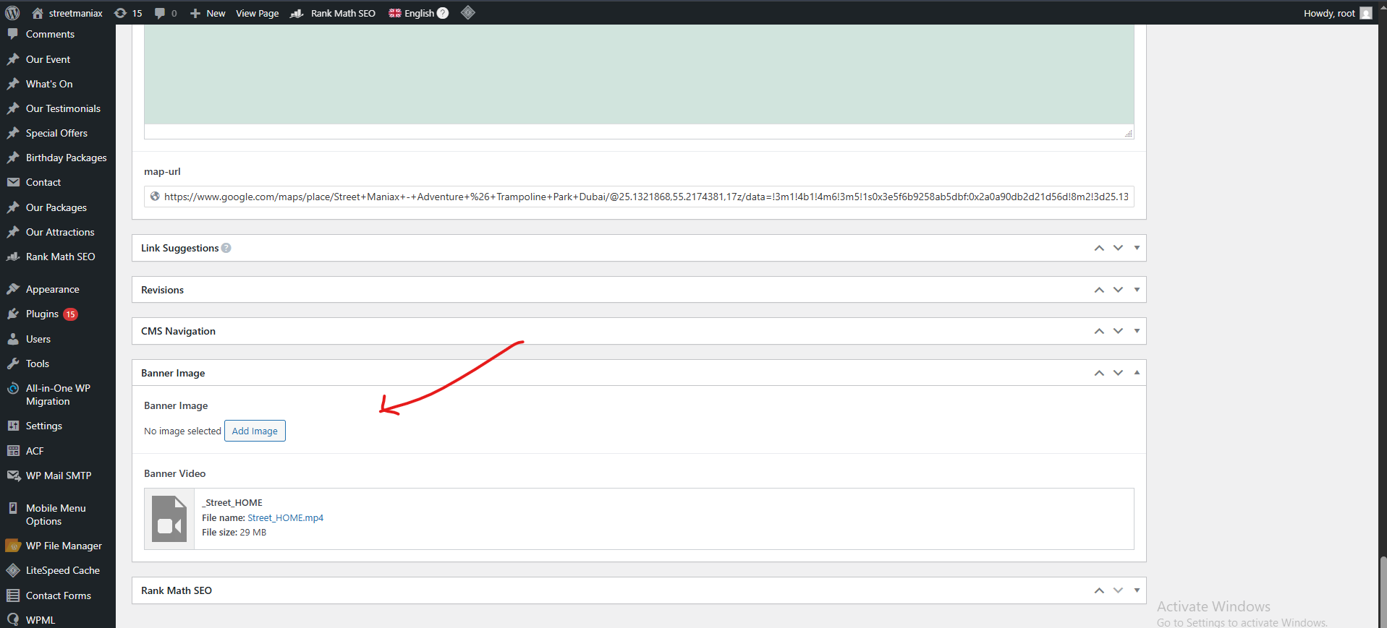

* In the Let the Fun Begin section you can arrange it from posts.

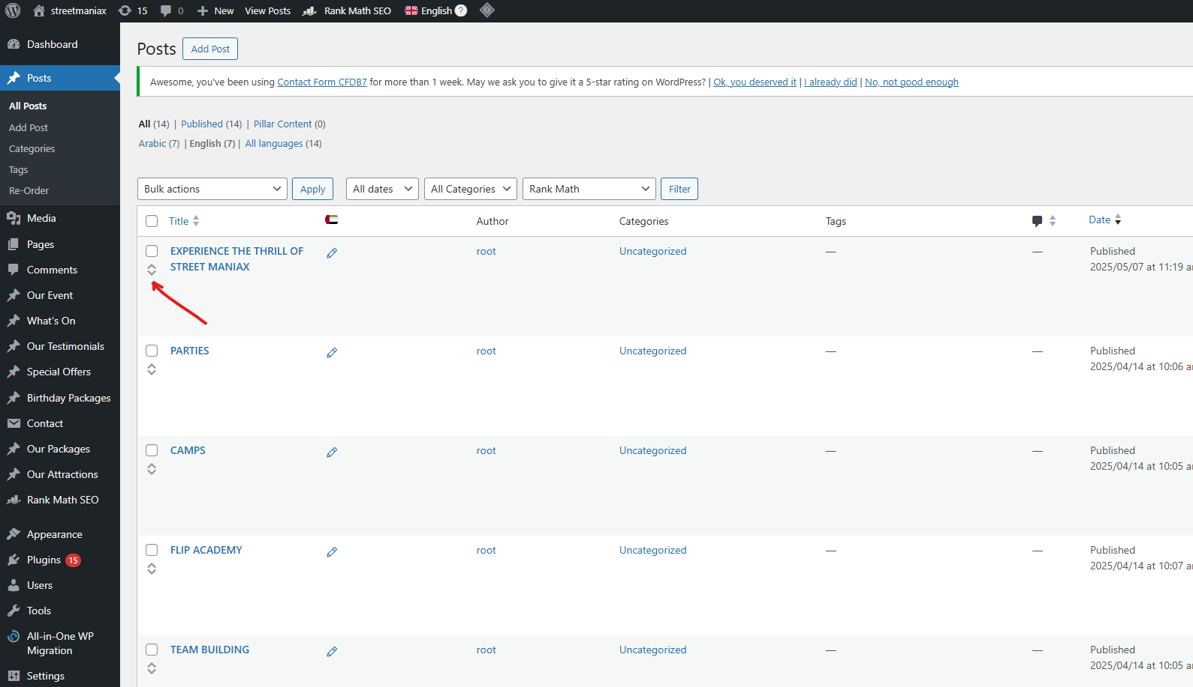

* In some pages, there are FAQ section for which you can edit it.

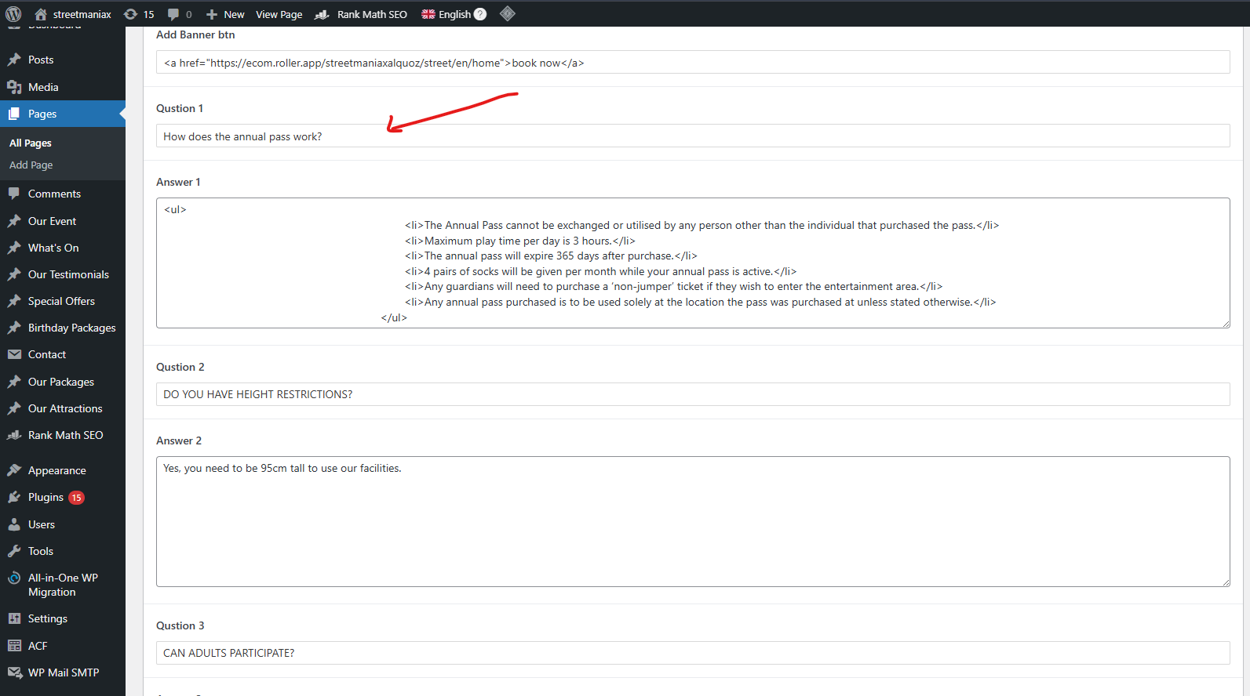

* Opening Hours page there is a small video in a section.

